HOTSPOTS FOR THERMAL DISCOMFORT & HEALTH RISK IN BISHAN - ANG MO KIO NEIGHBOURHOOD PARK

1. Introduction
The main focus of our project is on neighbourhood parks. The neighbourhood parks are primarily designed to serve as a social and recreational focal points for the community living in that area with access to various physical, social and recreational amenities such as playgrounds, fitness areas, jogging routes, benches, shelters, etc. They should be easily accessible to all, especially the children and the senior adults, who often frequent the park. Hence, with regards to needs of these two groups of people who are more vulnerable to their surroundings, which could have a significant influence in their physical and mental well-being. The neighbourhood park should not only provide the utmost comfort (thermal) but also medical or health security. With this in mind, our team has selected Bishan-Ang Mo Kio Neighbourhood Park as our study area and employed Geographic Information Systems (GIS) technology in the form of ArcGIS to find out the degree of thermal discomfort and health risk in the area.
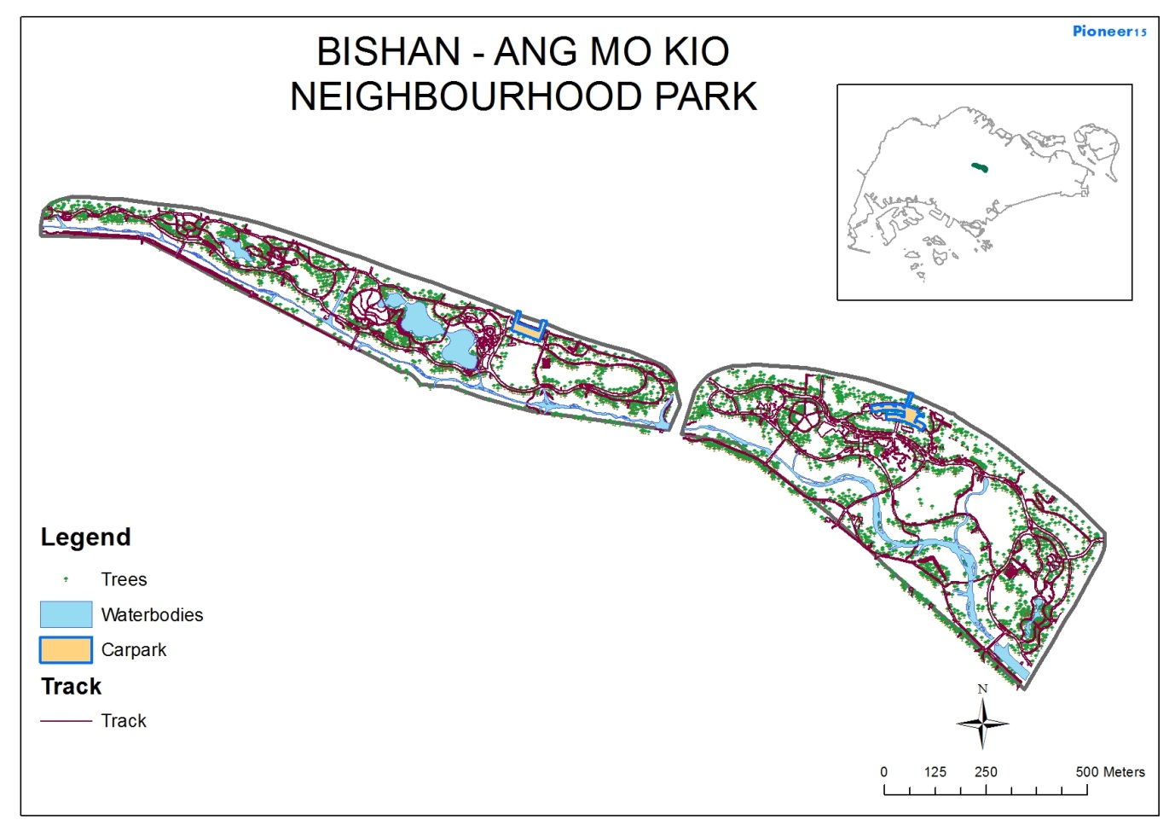
Fig.1 Map of Bishan-Ang Mo Kio Park, Singapore
2. Rationale
We strongly believe that the park should be catered to all groups in the community, in particular the more vulnerable ones, by providing a comfortable and healthy environment for them to interact in. When park users are patronizing the park, they should be able to relax and go around doing their own activities without worry. Thus, park designers have to ensure that the well-being of park users is thoroughly taken care off. This can be done through monitoring the people’s comfort level and the level of carbon monoxide. By analyzing the spatial pattern, distribution of heat index, carbon monoxide and trees that are able to absorb or sequester carbon, we will be able to identify potential areas or hotspots in the park that are prone to health risk and discomfort.

3. Research Objectives
Based on our rationale above, we aim to identify areas that have affected the park visitors in terms of thermal discomfort and areas with high health risk. Our research objectives, therefore, are as follows:
- To optimize the general social and recreational functionalities of the neighbourhood park through improving the level of comfort and health for its users.
- To determine the ‘hotspots’ or risk areas that are susceptible to high thermal discomfort - i.e. identifying areas with high heat index.
- To determine the ‘hotspots’ or risk areas that are prone to high health risks - i.e. identifying areas with high levels of carbon monoxide.
- To suggest methods to mitigate the high level of thermal discomfort and high level of health risks.
4. Research Methodology
Preliminary research was done by looking at the layout of the park through online resources like Google Earth’s satellite imagery to identify any potential problems that the park may have. Some of the potential problems that we identified early on were:
- Roads and carparks around the park can contribute high amounts of carbon monoxide to the park, increasing the health risk posed to users of the park.
- Many pathways are not shaded from the sun. As Singapore is in a hot and humid tropical climate, there might be increased risks of heat stroke if exposed to the sun without water for too long, particularly if unshaded.

4.1 Fieldwork Preparation
Prior to fieldwork, we prepared several digital spatial (map) layers using GIS software called ArcMap. We created the satellite image of the Bishan-Ang Mo Kio Park to get a better look at the park layout. The satellite images were taken from Google Earth software and thereafter georeferenced to fit into the ArcMap software. With the courtesy of Singapore Land Authority (SLA) and National Environment Agency (NEA), we were provided the various digital spatial layers of Singapore, in particular Bishan-Ang Mo Kio park to work with.

4.2 Fieldwork and Data Collection
The method of collecting data is rather unique via crowd-sourcing. In this method, the data is obtained or collected by enlisting the services of other students from secondary schools, junior colleges and tertiary institutions. The area of study is divided into 102 square grids and each group is assigned to 6 grids to collect the data for a minimum of 12 hours. After all the groups have collected the data, SLA will pool all the data together to make it available for every group to use in their project.
We conducted our field data collection on the 18th of June 2015 from 9am to 5pm at Bishan-Ang Mo Kio Park. We used the portable ‘SENSg’ microsensor datalogger linked up with the ‘ArcGIS Collector’ app to collect data on temperature, humidity, light, carbon monoxide and noise. Within the given 6 grids, we divided the grid in a systematic manner such that each grid will have 9 data collection points equally and evenly distributed. This is done so as to get a better sensing and better representation of data collection within the grid. After fieldwork, the collected data were then immediately uploaded using Wi-Fi to the server/portal managed by SLA for collation.
4.3 Post Data Collection
In this stage, we worked to improve our primary idea that trees have the ability to reduce the carbon monoxide levels and provide shade. Using the collected data, we scrutinized spatial data on the park’s trees provided by the NEA and SLA and conducted research to find out the best tree that can most efficiently absorb carbon monoxide from the atmosphere (carbon sequestration).
From the database, the park consists of over 200 trees species, and a total number of 3772 trees. Our research extended to identifying the most efficient species of trees that are capable of mitigating high levels heat index and carbon monoxide based on qualitative analysis of the girth size, canopy, branches and type of leaf (http://www.worldagroforestry.org). The trees which have a larger girth size, wider canopy, denser branches and broader leaves tend to absorb carbon monoxide the most and provide the best shade that could lower the levels of discomfort (heat index) as well as reduce the levels of carbon monoxide. In our analysis, we have identified the top ten numbers of trees in the park that have the potential characteristics to provide high levels of carbon sequestration (Table 1).
Table 1: Tree specifies with its characteristics pertaining to carbon sequestration.
 | Tree Species | Branches | Leaves | Canopy | Potential for Carbon Sequestration
1 | Samanea Saman (Jacq) Merr | Many | Broad | Big | Good
2 | Tabebuia Rosea | Few | Narrow | Big | Not good
3 | Crytophyllum Fragrans | Some | Broad | Small | Not good
4 | Carallia Brachiata | Many | Broad | Small | Not good
5 | Maniltoa Browneoides | Few | Broad | Big | Not good
6 | Khaya Senegalensis (Desr.) A Juss | Many | Narrow | Medium | Not good
7 | Cratoxylum Cochinchinense (Lour.) Blume | Many | Narrow | Big | Moderate
8 | Gymnostoma Rumphianum (Miq.) L.A.S. Johnson | Many | Narrow | Medium | Moderate
9 | Xanthostemon Chrysanthus (F.Muell.) Benth | Many | Medium | Big | Moderate
10 | Peltophorum Pterocarpum (DC.) Backer ex K.Heyne | Some | Broad | Medium | Moderate

We identified the tree species Samanea Saman (Jacq) Merr (Samanea SJM, also known as the Monkey Pod Tree) as one of the best trees to plant to achieve the above objectives. It has one of the largest average girth sizes in the park, with many branches spreading out widely. It also has wide and broad leaves; giving a wide and large canopy that is capable of providing shade in the park. As shown through the Heat Index (HI) distribution map (Fig. 2), areas without such trees tend to have a higher HI as compared to other areas. Assuming that the age and bark of the tree remain constant, the amount carbon it can sequestrate has a positive relationship between the branches, foliage and girth size. We have identified that there are 136 Monkey Pod trees within the park, but it has uneven distribution across the park and the density of such trees is rather sparse and cluttered. Some areas have clusters of them while some area that are completely lacking as shown in Fig. 3.
As the full calculation of carbon sequestration is extremely complicated and requires information we do not have, we have used information provided by the Envirothon to come up with a rough equation of how to do so. The equation that we have come up with is as follows: $\frac{1}{2}×(\text{1.26×}\frac{\text{Branches+Bark+Foilage+Wood}}{Age}\text{) }$

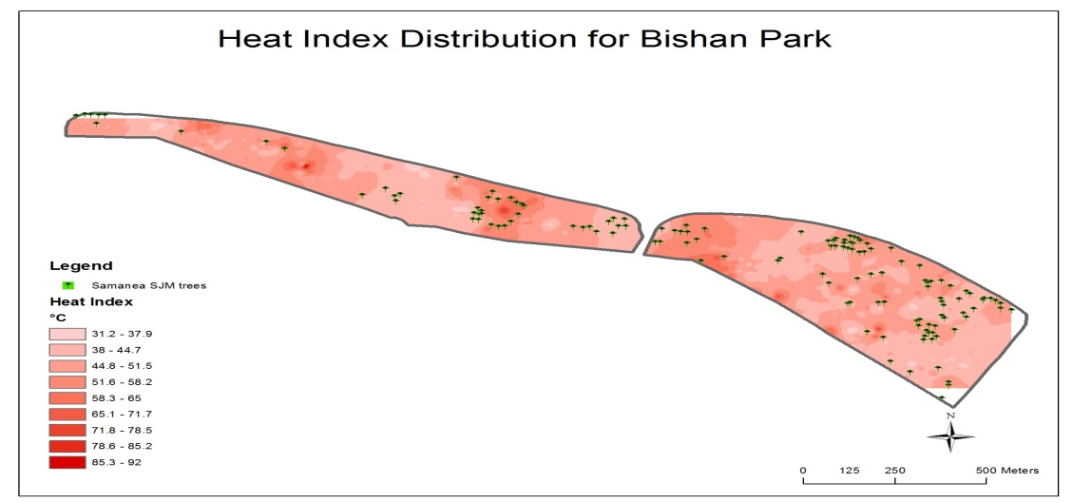
Fig.2 Heat Index Distribution in Bishan-Ang Mo Kio Park

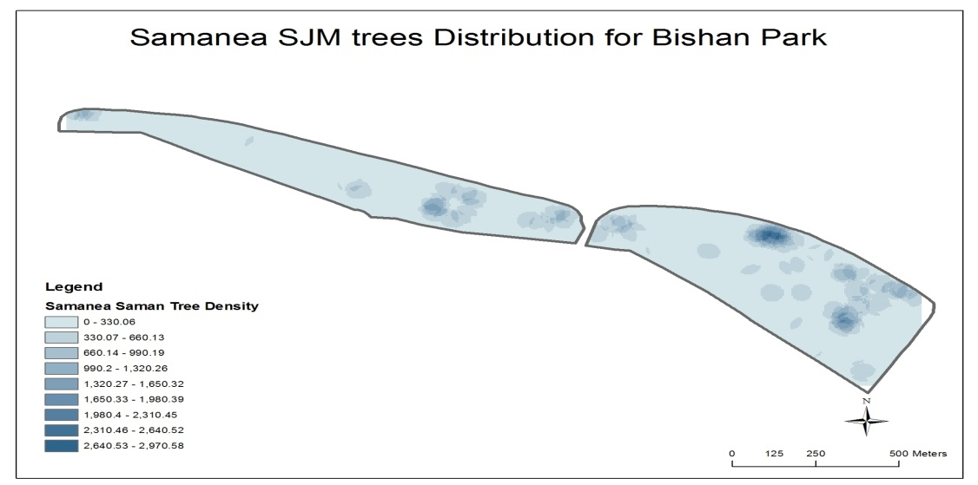
Fig.3 Distribution of Samanea SJM in Bishan-Ang Mo Kio Park

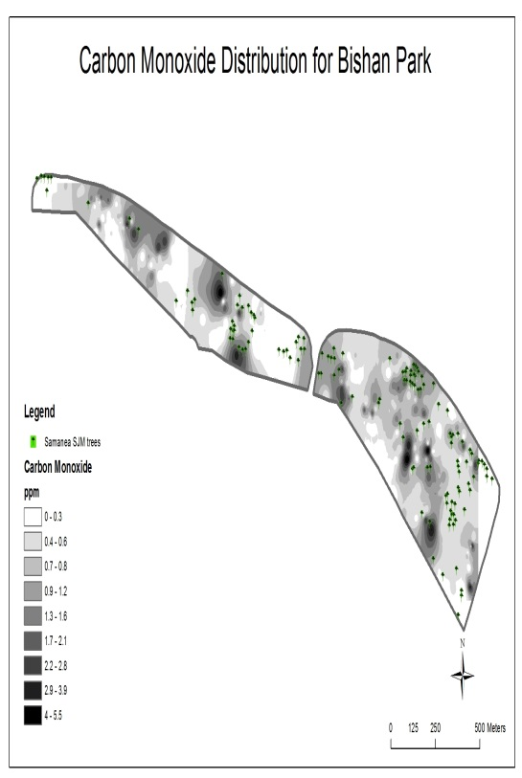
Fig.4 Distribution of Carbon Monoxide in Bishan-Ang Mo Kio Park

5. Processessing and Analysis of Data

Calculation of Heat Index
In order to achieve more comprehensive and yet more representative data, we merged both data layers from the JC pool and Secondary School pool. We then extracted data that are only found within Bishan-Ang Mo Kio Park for our study. Using ArcMap, we created a new field from the merged attribute tabular database using the Field Calculator function to calculate the Heat Index formula with humidity and temperature data. By calculating Heat Index, it provided a more accurate temperature felt by the skin instead of just the ambient temperature, thus is more representative of comfort level.

Interpolation of Heat Index, Carbon Monoxide and Tree point data into Raster Layers
As these data collected are in the form of point data, they are known as discrete data which has a known definable boundary – therefore, they are not suitable to show spread or distribution. In order to show distribution, the discrete data have to be converted to continuous data or surface data where each location on the surface is a measure of the concentration level. In order to do this, the point data are interpolated to produce a surface or raster map layer. These raster layers on each surface point has a given value or weightage and therefore will allow for quantitative, statistical or even spatial analysis. We have performed interpolation of Heat Index and Carbon Monoxide point data using the ‘Inverse Distance Weightage’ (IDW) tool in the Spatial Analyst function to produce the Heat Index Distribution Map (Fig. 2) and Carbon Monoxide Distribution Map (Fig. 4). As for the Samanea SJM trees, we performed the interpolation of its density using the Point Density tool in the Spatial Analyst function to show the clustering or distribution (Fig. 3).
Through these maps, we have identified a relationship between the heat index, amount of carbon monoxide and the distribution of the Samanea SJM trees. Generally, areas with larger open spaces and lower density of the trees have a higher heat index. We also found that carbon monoxide levels were higher near play-fitness and elderly-fitness areas. It should also be noted that the levels of carbon monoxide levels in Bishan-Ang Mo Kio Park range from 0 to maximum of 5.5 parts per million (ppm) as shown in Fig. 3. According to Carbon Monoxide Headquarters, CO exposures can lead to hazardous effects as shown in Table 2. The highest values (5.5 ppm) which are found in the park could lead to an increase in admission rate of non-elderly for asthma. Even a low value of 1ppm could increase the odds of un-medicated asthmatic children reporting symptoms the next day.

Table 2: Scale and Effects of Exposure to Carbon Monoxide
Scale | Effects
0 - 2 ppm | Range of CO found in end-tidal breath (ETCOb) of healthy non-smokers due to systemic but variable endogenous CO production.
1 ppm | associated with a 30% increase in the odds of un-medicated asthmatic children reporting symptoms the next day
3 - 4 ppm | Borderline range for ETCOb in non-smokers.
5 ppm | Lowest level of CO displayed by first-AIM low-level CO monitors (not approved by UL or CPSC).
3 - 7 ppm | A 6% increase in the rate of admission of non-elderly for asthma was associated with a change in CO
>5.5 ppm | CO level above this value during the last trimester of pregnancy was associated with a significantly increased risk for low birth weight
Source: CO Headquarters

Reclassification of Raster Layers
In order to perform quantitative analysis of the various layers, that is, to find the relationship between the layers via combining them through their values, we need to convert or reclassify these raster layers by giving values / rank to each of the range of their classes. For example, Heat Index raster layer is reclassified in such a way that the lowest class range will be assigned low value (1) and the highest class range assigned high value (9) as shown in Fig. 5. Similar reclassification is done for Carbon Monoxide raster layer (Fig. 6). However, for Samanea SJM trees raster layer, the inverse reclassification is performed. That is, its lowest range will be assigned high values (9) and the highest class range low value (1) as shown in Fig. 7.

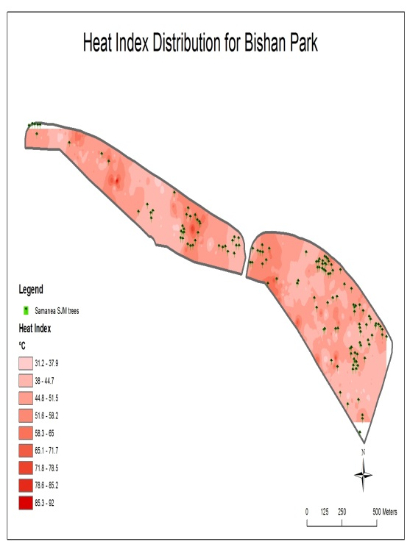  Reclassified |  | 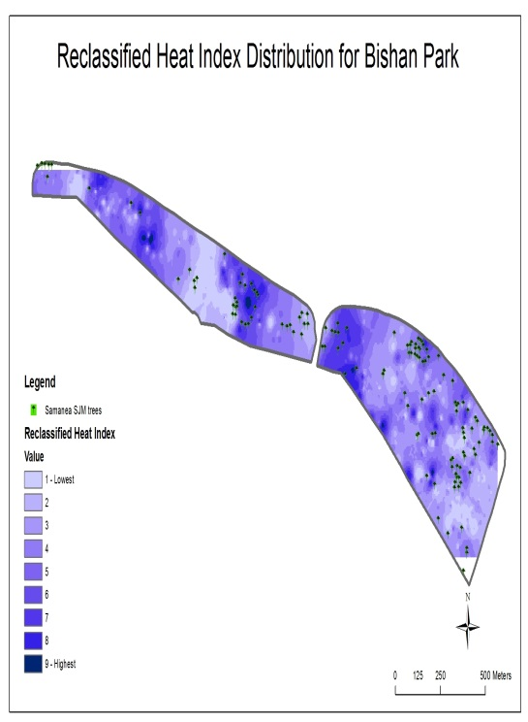
Fig. 5

Reclassified |  | 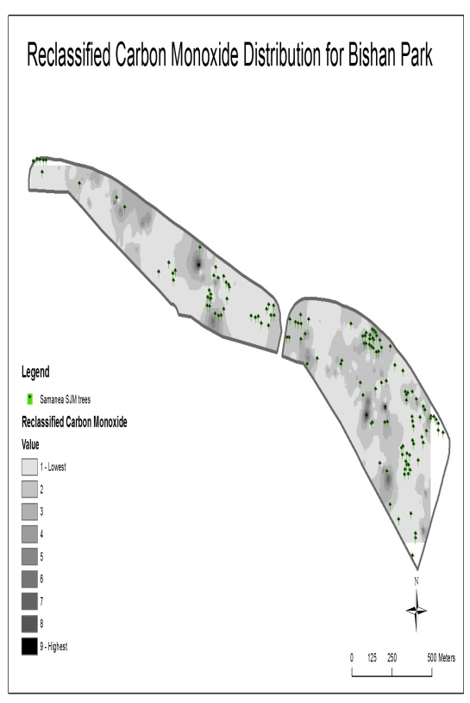
Fig. 6

Reclassified |  | 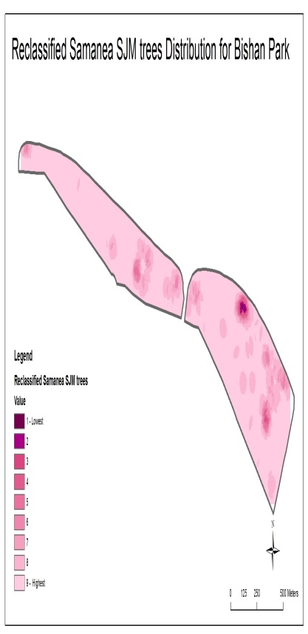
Fig. 7

Formulation of Hotspot Maps for Thermal Discomfort and Health Risks
In order to formulate the Thermal Discomfort map, we need to factor in or combine two variables: Heat Index and Samanea SJM trees. The hotspot for thermal discomfort will comprise of the highest heat index with the lowest tree density. Thus, using the earlier Reclassified Maps of both Heat Index and Samanea SJM trees, we combine both together by adding up their respective reclassified values using the Raster Calculator tool in the Map Algebra function of Spatial Analyst to produce the Hotspots for Thermal Discomfort in Bishan-Ang Mo Kio Neighbourhood Park (Fig. 8). Similarly, in formulating Health Risk map, we combine two variables: Carbon Monoxide and Samanea SJM trees to give the Hotspots for Health Risks in Bishan-Ang Mo Kio Neighbourhood Park (Fig. 9).
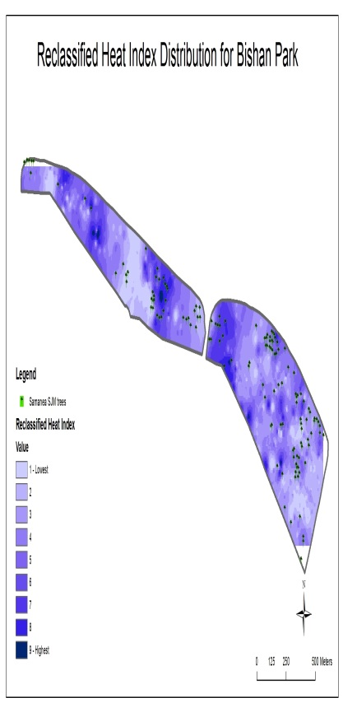
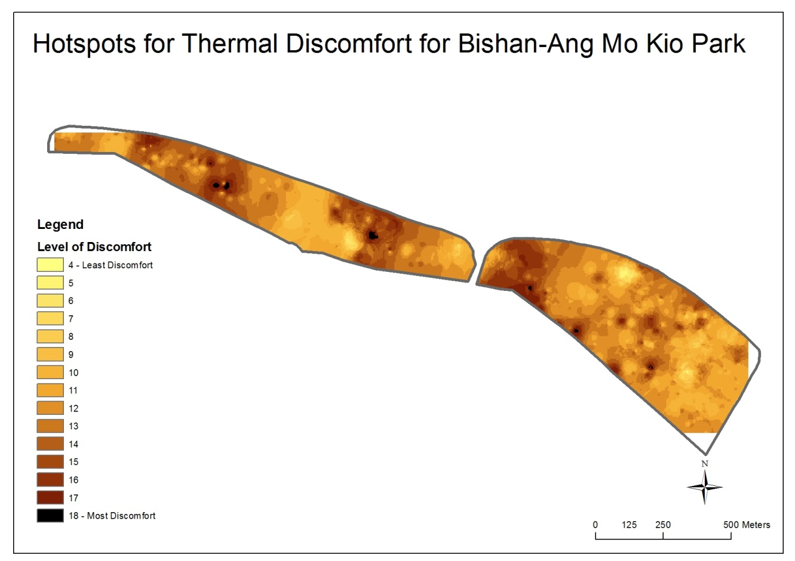
Fig. 8
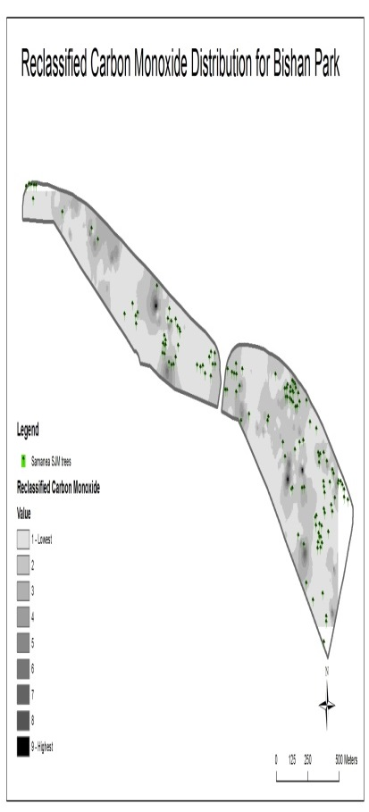
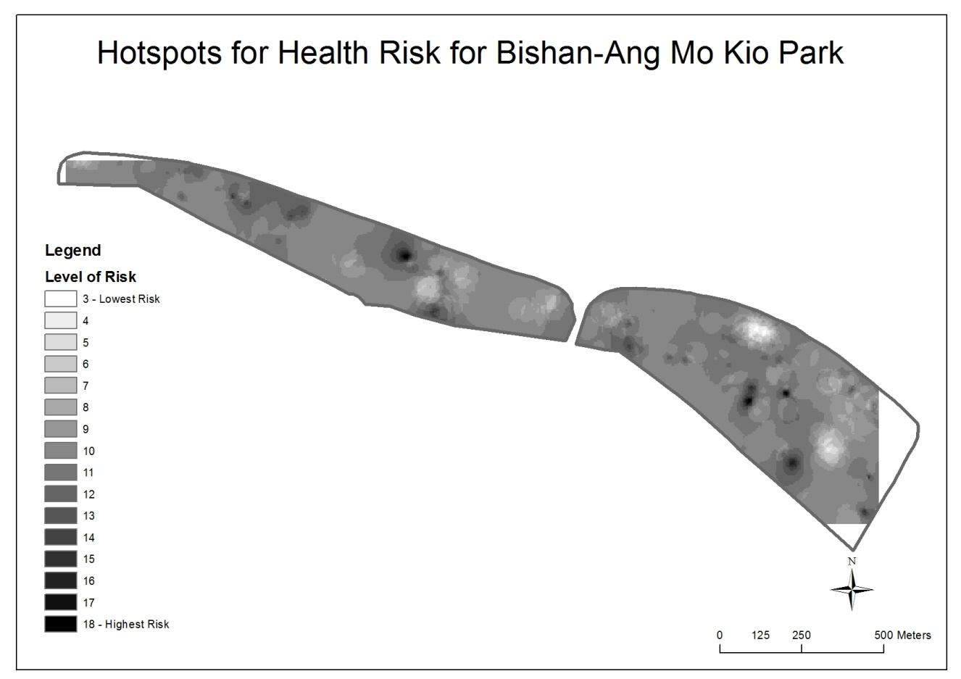
Fig. 9

6. Results and Discussions

Thermal Discomfort in Bishan-Ang Mo Kio Park
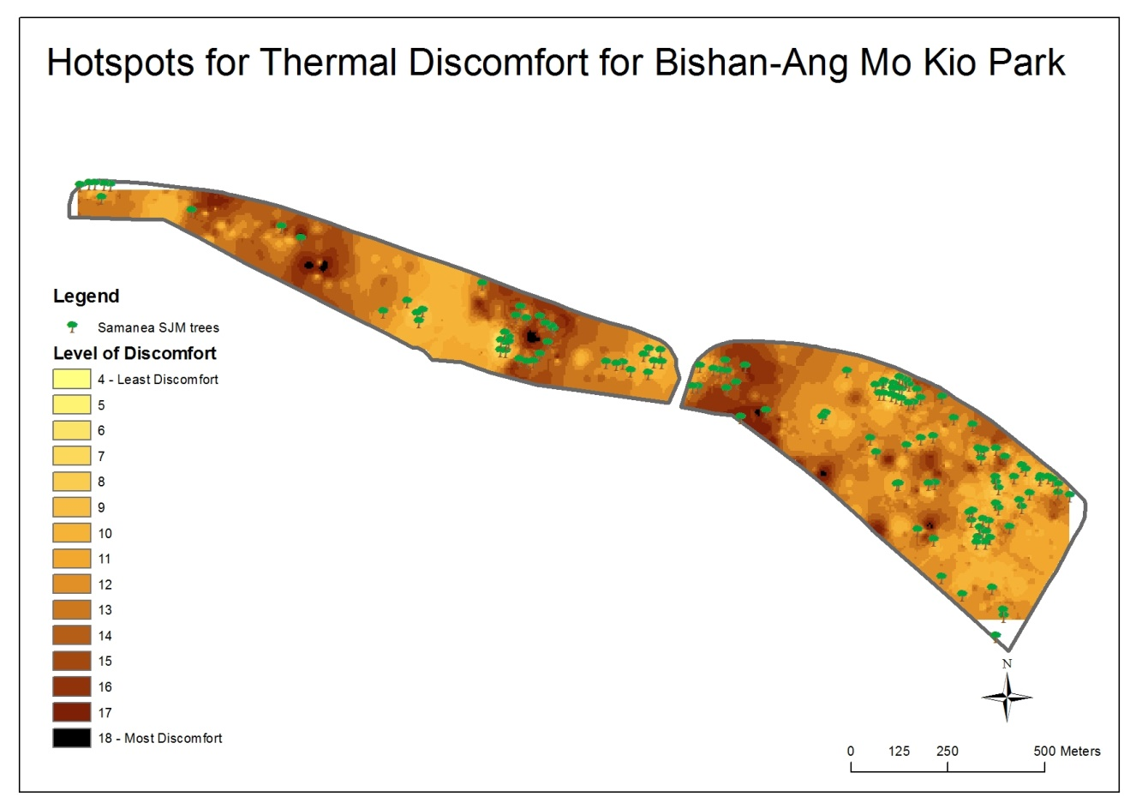Fig. 10
From the Thermal Discomfort Hotspot map, there is a distinctive pattern of areas having highest level of discomfort. For analysis purpose, the park can be divided into the West and East Wings. It can be clearly seen that on the East Wing, that the areas that are mostly found to be highly discomfort is located on the western section where there are less concentration of Samanea SJM tree. However, the remaining eastern section of the East Wing where most of the Samanea SJM trees are well distributed has a lower level of discomfort. At the West Wing, in general, the Samanea SJM tree is sparsely distributed compared to the East Wing. As a result, two distinct areas are found to be hotspots for thermal discomfort: the western and eastern section of the West Wing. Similarly, these hotspots are highly correlated to areas of less Samanea SJM trees.

Health Risk in Bishan-Ang Mo Kio Park
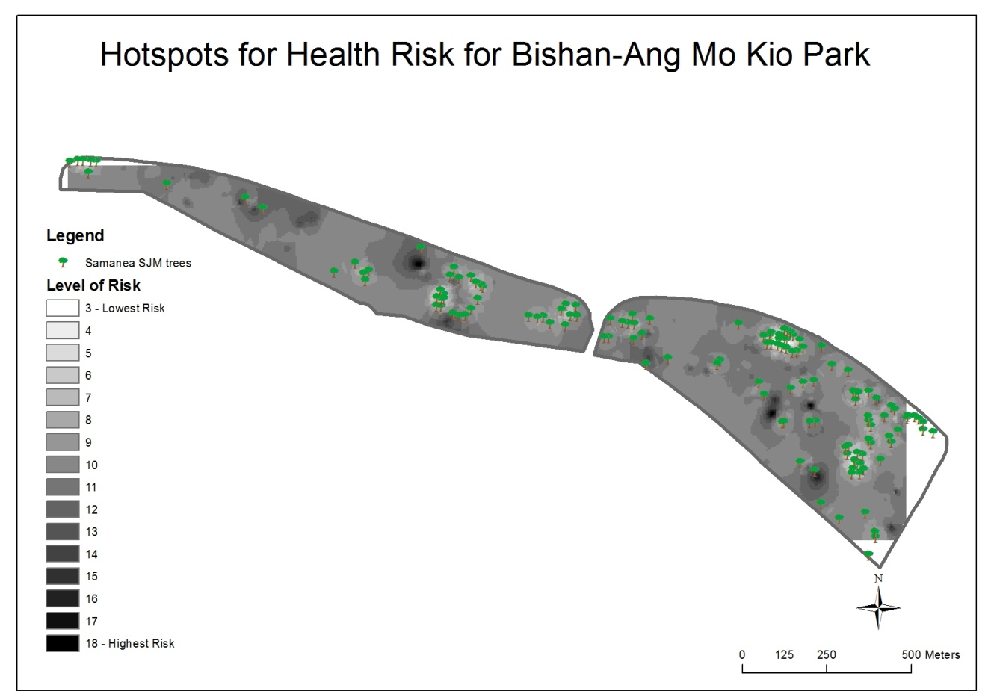
Fig. 11
Looking at the Health Risk Hotspot map, there is also a clear pattern of hotspot areas for high health risks (that is, high level of carbon monoxide). For both West and East Wings, two hotspots are found in the central section adjacent to play areas for little children and fitness areas for the elderly. Again, it is clear from the map that areas that have the lowest risk corresponds with areas with high concentration of Samanea SJM trees.
Unlike carbon dioxide (CO₂), carbon monoxide (CO) is a bad poison. When there isn't enough oxygen to make CO₂, CO is produced like in incomplete combustion. CO binds very strongly to the iron in the haemoglobin in the blood. Once CO attaches, it is very difficult to unbind them. In a nutshell breathing in carbon monoxide, causes it to sticks to haemoglobin and take up all of the oxygen binding sites. Blood loses all of its ability to transport oxygen, and the person may suffocate. As CO binds to haemoglobin so strongly, one can be poisoned by CO even at very low concentrations if they are exposed for a prolonged period of time.

Method to Mitigate High Levels of Thermal Discomfort and Health Risk
Hence, it is clear that trees tend to lower the heat index and carbon monoxide levels. The trees have helped increase the level of comfort in the park. As the distribution of trees in the area increase, the comfort level rises. There are areas in the park where there is a fairly high heat index or have little to no distribution of trees. This leads to low levels of comfort in those areas. Thus, we suggest planting the Samanea SJM tree near or within those areas in order to bring down the high heat index and thus increase the comfort level. The trees are also big and wide enough to provide shade for the park users, which further increase their comfort levels.
This issue should be looked into within the two age categories, mainly elderly and children, which frequent the area. They tend to be more susceptible to the surrounding elements of carbon monoxide and heat due to weaker immune system. This is especially so when they are exerting themselves more when using the equipment there. As the Samanea SJM species can help greatly in reducing the level of carbon monoxide, more of them should be planted around those areas to absorb the carbon monoxide. This would benefit the health of people within the area.

7. Conclusion

The well-being of park users is of the utmost importance to the park designer. The park users should be comfortable when using the park and they should be assured that their health is not compromised when using the park. Parks are areas that people go to relax and they are generally promoted as being one of the healthier places to be in within an urban area. Thus, comfort and health must be looked into to provide a wonderful park experience that everyone deserves.

Although crowd-sourcing is beneficial in providing comprehensive data, we must treat the data with caution. As the crowd-sourcing method involved several groups from different schools, the way in which each groups collect the data would be different (e.g. different timing and different day). Hence, there is a higher tendency for the data collected to be less systematic, which may compromise the representation of the data. The use of different data sensors without calibration could also result in variations in the data accuracy when merging the two groups of data. Despite these shortcomings, the crowd-sourcing data is still very useful for our project as it is able to give a viable geographical pattern of the phenomena studied.

References:
http://www.worldagroforestry.org
http://www.yukonenvirothon.com/carbon-sequestering-calculations.html
http://www.coheadquarters.com/ZerotoMillion1.htm

http://www.yukonenvirothon.com/carbon-sequestering-calculations.html
Heat Index formula = -42.379 + 2.04901523*T + 10.14333127*RH - .22475541*T*RH - .00683783*T*T - .05481717*RH*RH + .00122874*T*T*RH + .00085282*T*RH*RH - .00000199*T*T*RH*RH
http://www.coheadquarters.com/ZerotoMillion1.htm

